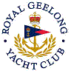 | Royal Geelong Yacht Club Inc.  Est 1859
Trophy Deed of Gift.

Trophy: | Beta Tray (Not to be confused with Beta Cup)
Presented by: | Mrs. Kennedy
Date: | 1955
For: | “C” Class Perpetual Aggregate
Remarks / Revisions | Large Silver Tray  Originally presented an Open Yacht Race” on 31-March-1894, by J. Bracebridge-Wilson, and won by Dr. Kennedy’s “Beta”  Dr. Kennedy was then Commodore of RGYC.  J. Bracebridge-Wilson past headmaster of Geelong Grammer School  1990: Reassigned to best Performing boat in ORCV Series  2006 Reassigned to Division III Aggregate
Click here for ORCV Series Recipients
Click here for Division III Aggregate Winners

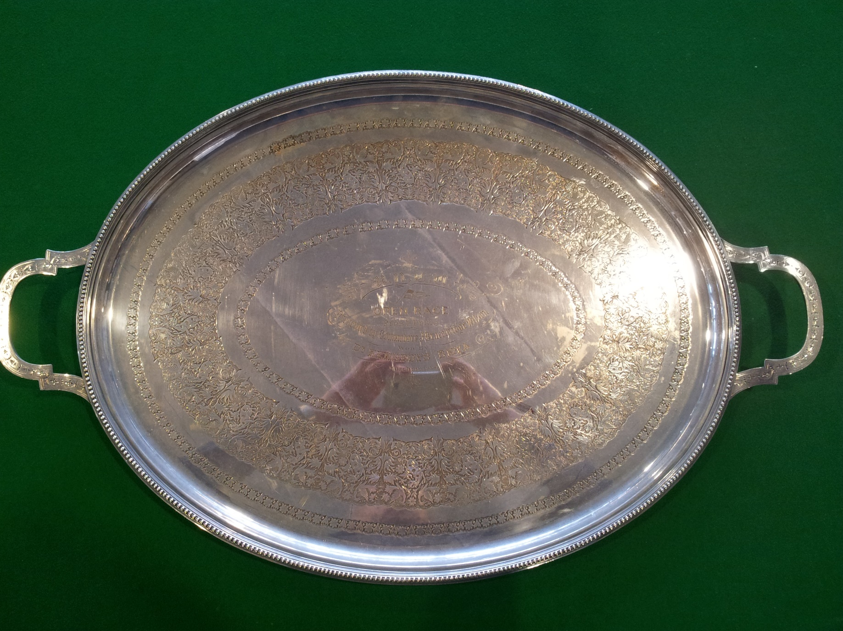

2006-2006 => 2009-2010 Div. III trophy was the International Red Hand Trophy

